Updated Problem Statement

"Multi Test Case Summary Formatter"
Write a Python script that:
- First asks: How many test cases do you want to enter?
- Then loops that many times and for each test case asks:
  - Test case name
  - Test status (Passed, Failed, Skipped)
- After all inputs are collected, prints a full formatted summary for all test cases at once like this:
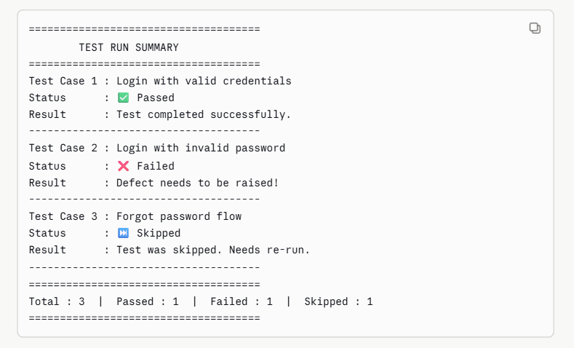
Acceptance Criteria
- User enters count first, then enters all test cases
- Nothing is printed until all inputs are collected
- Summary shows correct emoji and result message per status
- Final line shows correct totals
- Handles unknown status gracefully

